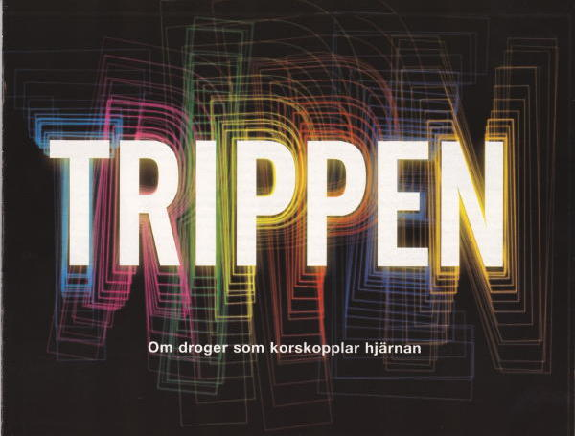

WITH PSYCHEDELIC DRUGS IN THE HUMAN BRAIN

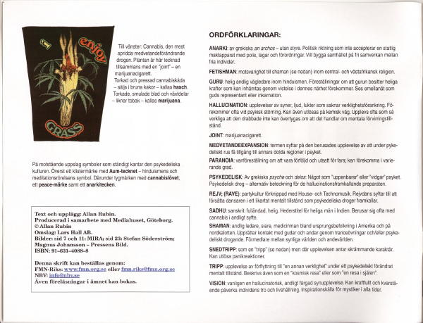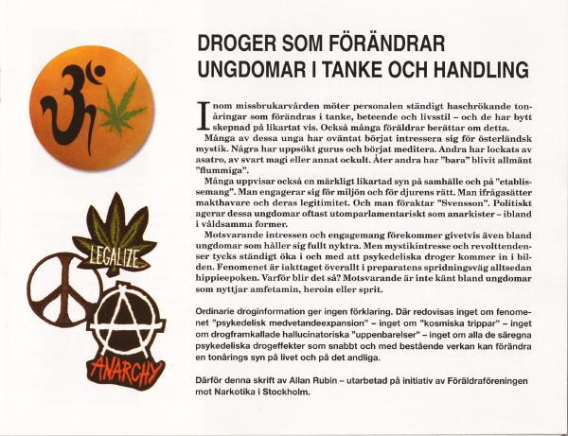

1 - Can drugs change values and lifestyles of the users?
Here the question is put why many users of psychedelic drugs, (LSD, mescaline, hashish, marihuana etc.) experience personality change. Many teenagers unexpectedly become interested in shamanism and eastern religious mysticism. Some develop a new passionate concern for the environment and a stronger inclination to revolt against people in position of authority, western lifestyle and "the establishment". Users of alcohol, amphetamines or heroin do not exhibit such patterns.
Official drug information does not offer any answers to this question.

page 1/15

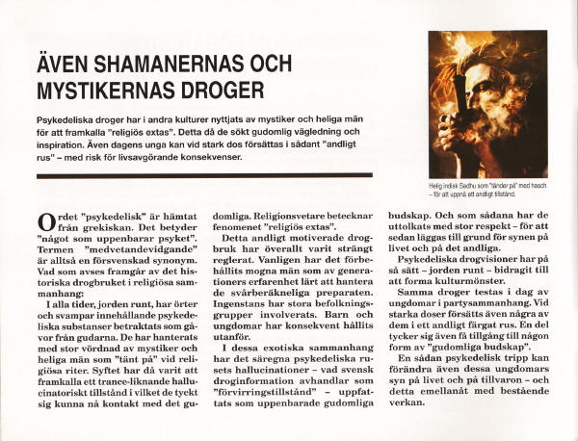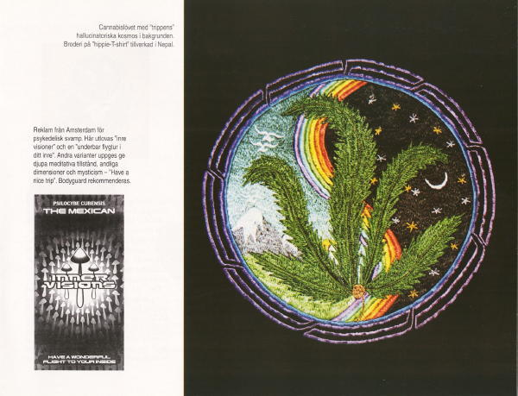

2 - The drugs used by shamans and mystics.
This passage describes how herbs and mushrooms containing psychedelic substances in many cultures have been regarded as gifts from the gods and how these plants have been used by mystics and holy men in order to reach a hallucinatory state of "religious ecstasy".
In such ancient rituals, the psychedelic hallucinatory visions have been interpreted as messages from the world of the spirit - as revelations - and as such they have had a powerful effect on the surrounding culture, shaping both lives and systems of value.
The very same drugs are being used today among western young people. Some of them then, unexpectedly, find themselves exposed to experiences of "divine intoxication". Also among those teenagers such a "trip" may, like a revelation or a conversion, change the teenager's outlook on life and existence - for good.

page 2/15

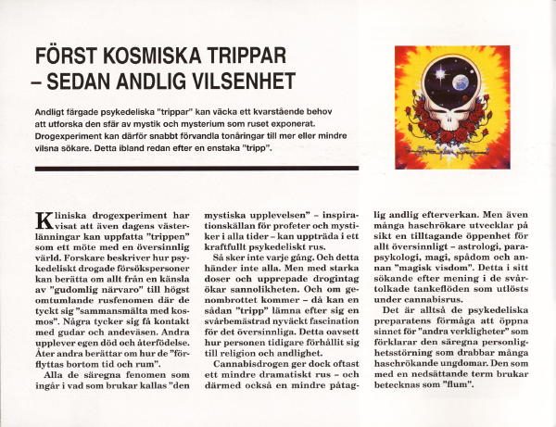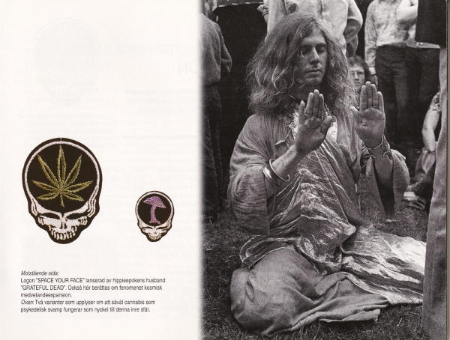

3 - Cosmic consciousness - and spiritual disorientation.
The psychedelic experience can be interpreted as a meeting with the supernatural: unsettling encounters with gods and spirits, merging with forces on a cosmic scale, experiencing one's own death and rebirth, moving beyond time and space, and having feelings of divine presence. All the elements traditionally included in what we call a mystical experience may be part of a psychedelic trip.
Such experiences do not occur every time, nor do they happen to everybody. But with repeated use and strong doses, the likelihood for it will increase. And such an experience may leave behind an enduring fascination with the supernatural - even among those who earlier did not seem particularly interested in spiritual matters.
The "cosmic trip" has in this way rapidly transformed many ordinary teenagers to deeply confused seekers of religious experiences - to "space cadets", looking for answers in astrology, parapsychology, and various forms of "magic wisdom". And this many times already after a single powerful "trip".

page 3/15

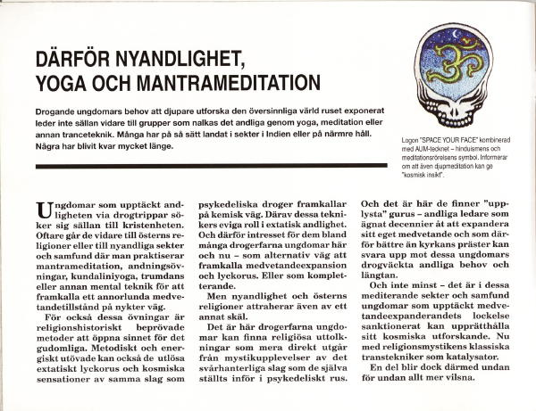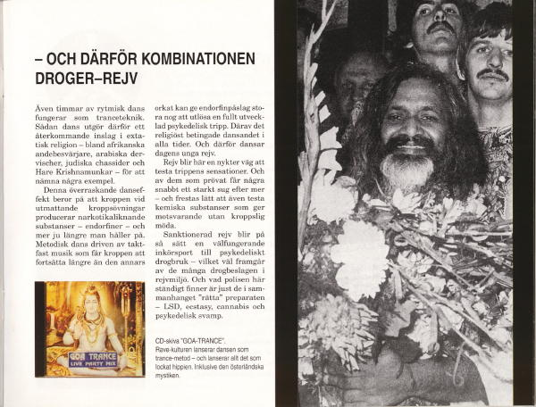

4 - New Age religiosity, yoga and manta meditation.
This passage describes how also certain forms of meditation, hyperventilation, yoga and related mind altering activities in many cultures have been used - and are used – in order to trigger spiritual experiences similar to those that come with the psychedelic drugs. That can explain why many psychedelic experienced teenagers also find these techniques interesting - as an alternative or a complementary means to reach mind expansion, altered state of consciousness, euphoria and spiritual inspiration. Hence also their special interest for cults and sects based on eastern religions and for new-age religiosity. Here they find meditating spiritual leaders with a personal mystic experience of the kind which these young persons have encountered during mind expansion. And here they can proceed with their cosmic exploration – this time with mind expanding techniques as tools.
In the hands of such guru-led cults many of these now meditating youngsters, with time become still more confused.
(On the page to the right, the focus is on rave dancing as a modern version of ecstatic dancing, similar to the dancing of dervishes, African exorcists, and East European Chasidism. Also rave dancing can release drug related experiences - and thereby awaken the temptation to also try out chemical substances which induce ecstatic trance states without physical exertion. Hence the noted connection between rave dance and use of ecstasy, cannabis, LSD and psychedelic mushrooms.)

page 4/15

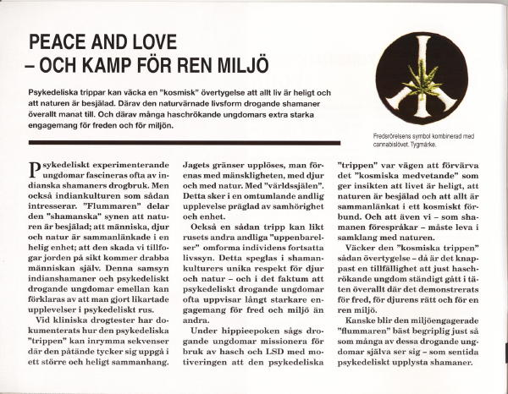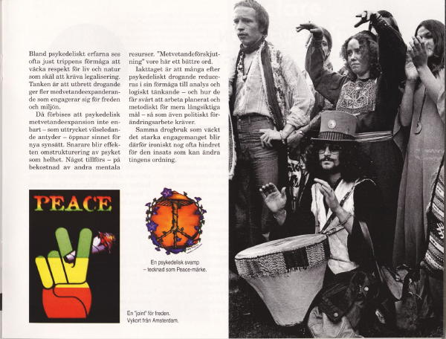

5 - Peace and Love - and fighting for a clean environment.
Here is described how the psychedelic experience may include sequences when the intoxicated person experiences a feeling of boundlessness and becoming one with the universe, with the world spirit, with all of humanity, with plants and beasts. Such experiences, being part of the holy chain of being, may leave an enduring religious conviction similar to the one known from of the drug using Indian cultures - the shamanic view that beast and man are linked together in a holy chain of being; the hurt we do to the earth, to its plants and creatures, will end up by hurting human beings too.
Also young people of today can, through use of "shaman drugs", acquire such a spiritually colored "shamanistic" respect for life and for our environment.

Are the young environment-caring, "cosmic consciousness people", best understood the way many of them see themselves - as contemporary, drug-enlightened shamans?

page 5/15

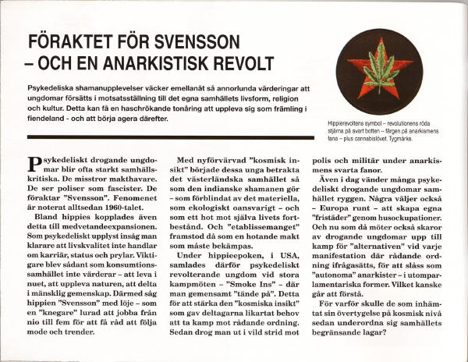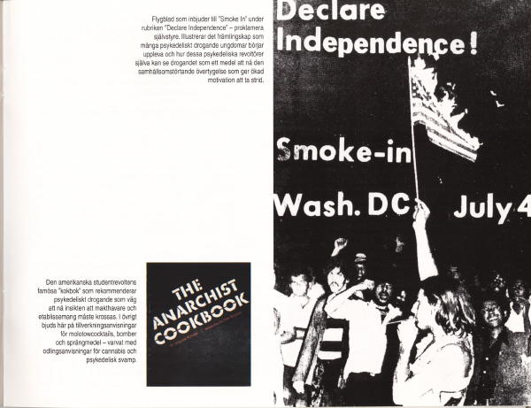

6 - Contempt for the life of the common routine - and anarchist rebellion.
It is observed how many psychedelic experienced teenagers tend to be extremely critical of society and suspicious of people in positions power. They see the police as fascists and many of them are full of contempt for the ordinary man. Can even this be tied to the psychedelic change of the mind?
Many of these young men and women explain how their drug induced "cosmic consciousness" has made them see differently – that the good life is not about career, social status, or the accumulation of material belongings – that western civilization is just as destructive as the Indian shaman describes: ecologically irresponsible, blinded by material things and hence a threat to the survival of the planet and to all living things.
During the hippie era this psychedelic mind altering effect was also exploited for political purposes when marihuana was smoked at "smoke-ins" - meetings of anarchists – before their going out to fight the police and the military in the streets. This in order to reinforce the inner convictions that motivated these psychedelic rebels to fight against the established order.
Have we overlooked that the psychedelic consciousness change can bring forward values and perspectives which set teenagers on a collision course with their own culture and lifestyle – and that this makes some of them start to see their own family environment as enemy territory – and to act as if that were the case?

page 6/15

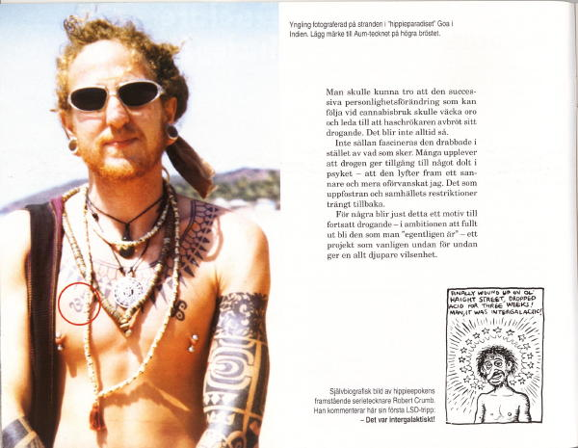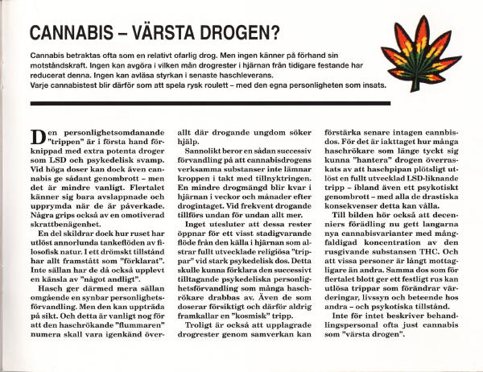

7 - Cannabis - the worst drug?
The personality changing "trip" is mainly associated with potent drugs like LSD and psychedelic mushrooms. The cannabis effect is in general less dramatic and not usually associated with immediate personality change.

But use of cannabis leaves traces of the active substance - THC - in the brain where it remains for weeks and months. When taken repeatedly such drug rests are stored in increasing quantities. Does this cause a delayed psychedelic effect and concomitant personality change - without the "cosmic breakthrough" stage described earlier?
It is also observed that the effect of cannabis varies widely from one person to the next. The drug puts some people just in a relaxed party mood while others describe dramatic religious life transforming experiences. And there are still others whose mind crashes and they become psychotic.

In addition: the strength of a cannabis dose can vary widely from one time to the next. No one can in advance estimate his/her personal level for a break through. Every cannabis test will therefore bee like playing Russian roulette - with the drug users personality at stake.

page 7/15

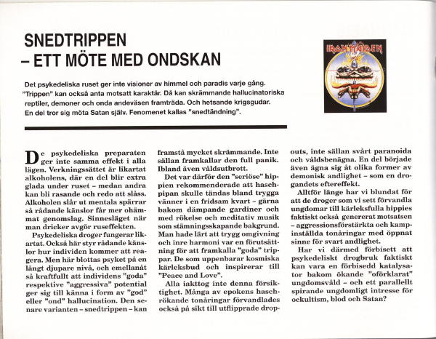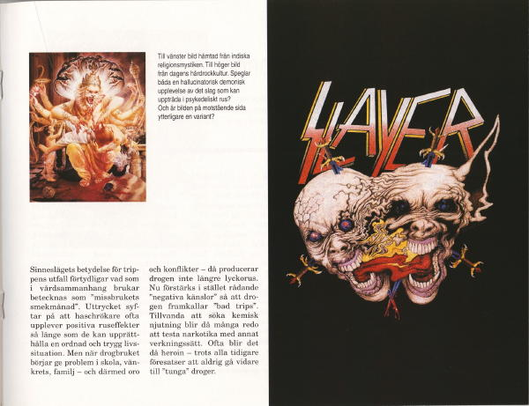

8 - The bad Trip: an encounter with Evil.
Psychedelics, like alcoholic beverages, produce different mental effects, depending on the mood in which they are taken, and we know that the "trip" can either acquire a "cosmic" or a "demonic" quality. In the latter case frightening hallucinatory demons, evil spirits and frenzied warlike gods may appear during the intoxication. Among drug users this phenomenon is known as a "bad trip".

Also such a meeting with “the demonic” can – like “the cosmic trip” have an enduring effect on the personality - but now of a demonizing nature.
Have we overlooked that the very same drugs which we have seen transform young people into peace loving hippies drawn to eastern mysticism, also can generate the opposite – aggression heightened teenagers, paranoid and rapidly ready to fight - and with a psyche open to black spirituality?

page 8/15

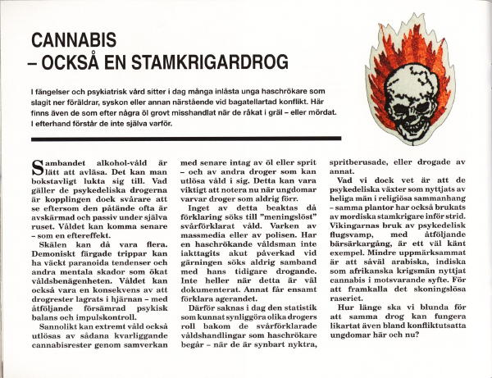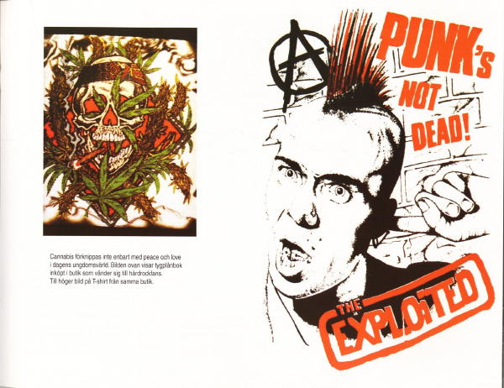

9 - Cannabis - also used by tribal warriors.
This passage describes how the demonizing effect of psychedelics has been explored in other cultures – how the very same plants which have been put to religious use among mystics and shamans also have been taken by tribal warriors facing battle - in order to release unreflecting fury. A well known example is the use of fly agarics among the Vikings - in order to go berserk. Also cannabis has been used for the same purpose, in the Middle East, in India and in Africa.
Not much research has been into this aspect of the hallucinogenic drugs. But, among the inmates in prisons and mental hospitals, there are to day many young cannabis users who have knocked down parents, other family members or friends after disagreement over a trifle. There are also those who suddenly and without mercy have physical abused or murdered people with whom they have quarreled.

Afterwards they have not been able to understand why.

page 9/15

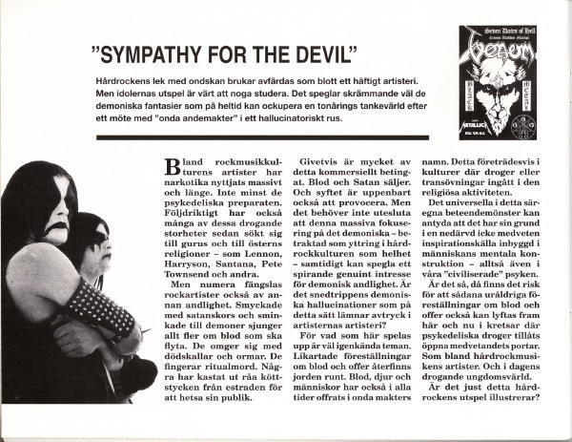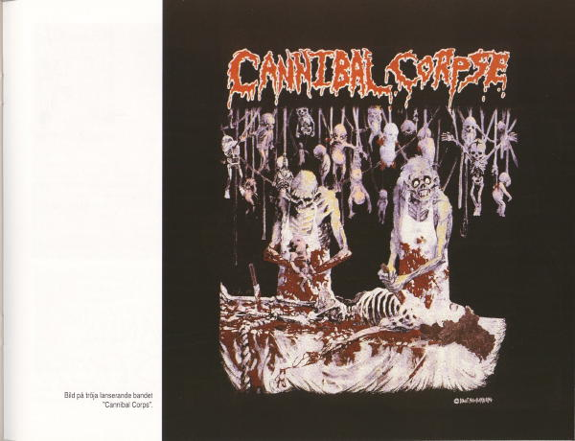

10 - "Sympathy for the Devil".
Can hallucinatory insights into a world of evil spirits awaken an enduring interest in the occult, in black magic and Satanism? And is this what the artistry of drug using rock music artists now illustrates? Is their thematic play with demons, blood and sacrifice inspired by hallucinatory meetings with Evil?
Of course, much of this offering is based on a commercial speculation. Blood and Satan sell. And clearly, the aim here is to be provocative. But can it be ruled out, that this kind of extreme focusing on the demonic – when looked upon the hard rock culture as a whole – also might have its origin in hallucinogenic experiences?
What this culture offers of ply with blood rites and sacrifices is well known from religious life in many cultures where trance activities and/or psychedelic drugs have been used for spiritual purpose.

Does psychedelic drug use arouse similar tendencies also here and now? Is this what the rock music culture now mirrors?
What those hard rock artists today offers is well worth looking at more closely. Nothing can better reflect the demonic fantasies which may fill the mind of a teenager after a bad trip which has exposed him to evil spirits during a hallucinatory trip.

page 10/15

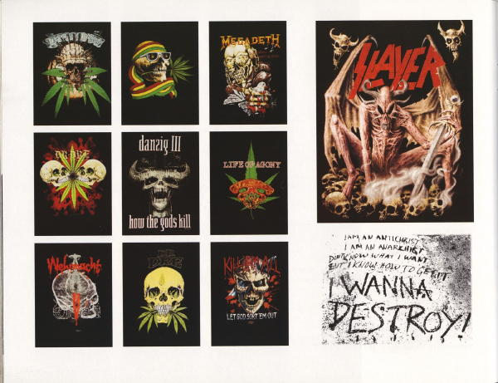

11 - When "Peace & Love" becomes "Hate & War"
The spread shows images on T-shirts now being sold in stores, which specialize in paraphernalia from the rock music culture.

Do the motifs suggest that the drugs that since the hippie-era have been associated with eastern mysticism, brotherhood and "Peace & Love" alternatively can release a youth culture based on demonic fantasies, paranoia and "Hate & War"?

page 11/15

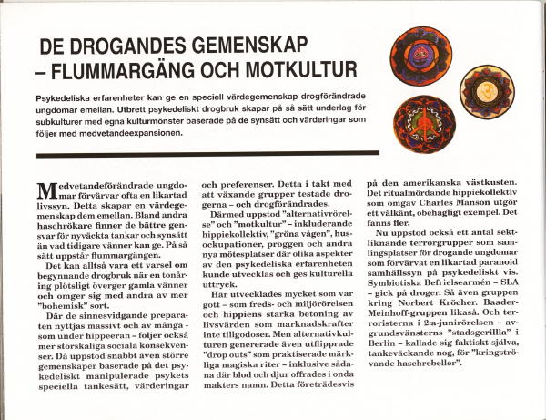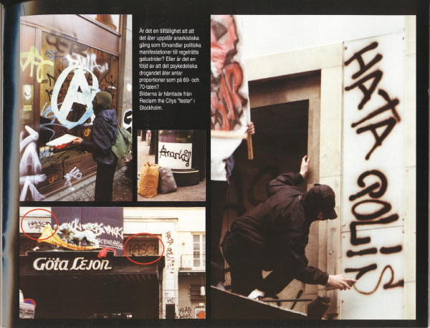

12 - The spaced out kids – and the counter culture.

Here is described how psychedelic experiences can give a special sense of community of values to young people who have shared the experience of mind altering drugs. Can wide spread drug use therefore form the basis of subcultures with specific cultural patterns, based on the values and perspectives which the mind expanding drugs bring to the surface?
Is this the background for "counter culture", "hippie communal living", "country communes", and "house occupations" - and also for a number of extreme religious and political sects, including drug using terrorists - such as Bader-Meinhoff, the Symbionese Liberation Army, the group of terrorists around Norbert Kröcher - as well as the “urban guerilla” in the June 2nd movement in West Berlin.

They spoke of themselves as "nomadic hashish rebels ".

page 12/15

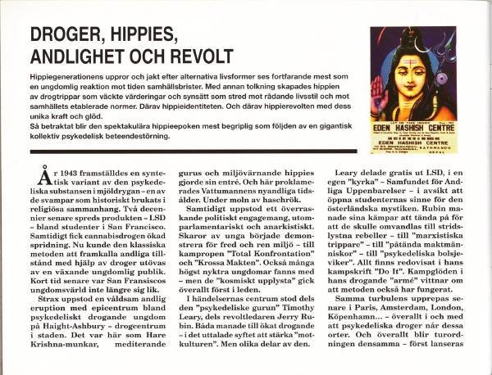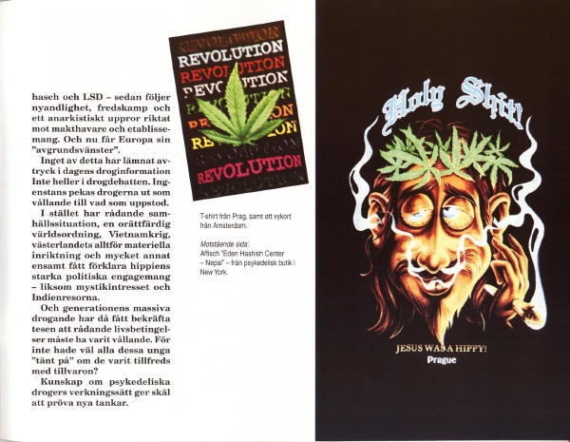

13. Drugs, hippies, new age spirituality and revolt.
This passage gives a summary of what happened when cannabis and LSD first got introduced into American youth culture - how almost immediately a wave of "new age" religiosity and rebellious revolt followed, a pattern which later was repeated in other Western countries in the wake of the spread of the same drugs. And everywhere the course of events was the same: first experiments with psychedelics, then new age religiosity, fight for Peace and Love and search for alternative lifestyles. All this combined with an anarchistic revolt against people in power and against the establishment.
Till now all this has been explained as a reaction of the young against failings in society. To the exclusion of every other explanation. But looked from a different perspective this “hippie revolt” can also be understood as the result of a gigantic collective drug induced behavioral disorder – as a consequence of drug trips that have awakened new values and ways of thinking diametrically opposed the ruling lifestyle and established norms.

Was it in fact the psychedelics that gave us the hippie revolution - with its unique strength and passion? For better and for worse.

page 13/15

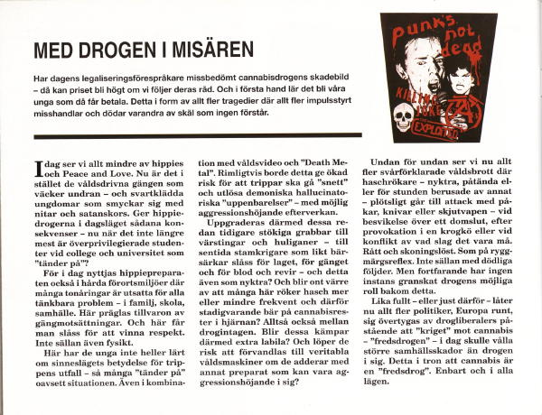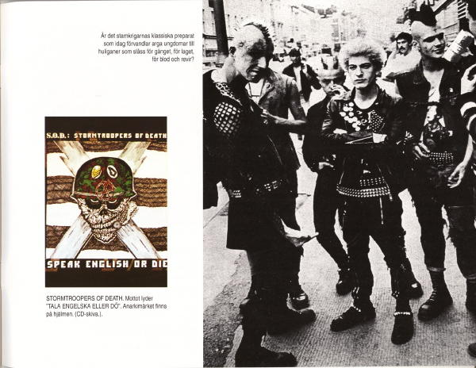

14 - With mind expanding drugs in social misery.
In the 60-ties the psychedelic drugs mainly were used by privileged students. Now the same drugs are to be found even in problematic social environments characterized by conflicts and all kinds of social problems. Does this increase the risk for “bad trips” and demonic, hallucinatory visions – and for a “demonic” personality change.

Will such“bad”drug experiences among teenagers with earlier tendencies towards violent and uncontrolled behavior convert some of them into berserks and hooligans, ready to fight for the team, for the gang, for blood and territory? As a psychedelic after effect? Even when sober? And will present widespread habit of combining different drugs increase this problem?
Is this an contributing explanation to why many teenagers today - when stoned, under the influence of drugs in combination – or apparently sober but with drug rests in their brains - suddenly go to attack with sticks, guns or knives when they are provoked in any way. Not seldom with deadly outcome. As a knee jerk reaction.
Not much research has been done concerning how an psychedelic “trip”can change personality and behavior. Nor about the mental effects related to stored cannabis in the brain. Hence we can not tell to what extent the use of cannabis contributes to the increasing violence in youth culture – and in society as a whole.

Yet a growing number of organizations today loudly advocate legalizing cannabis.

page 14/15

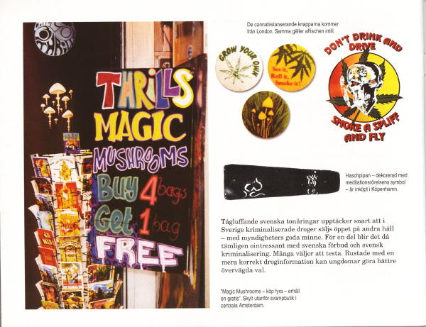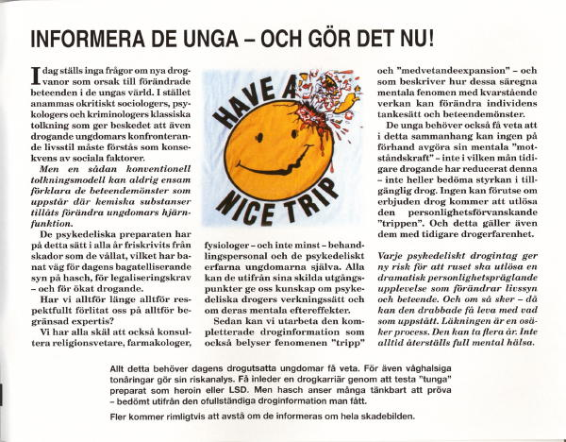

15 - Inform the youth. And do it now.
For decades psychologists and criminologists have explained that young people's confrontational behavior - including their drug use - must be understood as an answer to social problems. This conventional model of interpretation can never, by itself, explain behavior among persons using chemical substances that alter the function of the human brain.
Only when we also take into consideration the phenomena that drug users call "trip" and "mind expansion" we will be able to understand the role of the psychedelic drugs behind the change of thinking, behavior and lifestyle in youth culture of to day. And only then will we be able to give our teenagers a more correct drug information also warning for the psychedelic personality change – and describing how those who get affected may have to live with the outcome. The healing process is uncertain. It can take years. Not every one recovers fully.
All this young people need to be told. Now. For today among young people cannabis is regarded as a relatively innocuous drug – based on present incomplete and reductive drug information they receive. Hence many are ready to make a test when opportunity arises.

Many youngsters will refrain from trying when they are informed about the full extent of the damage a psychedelic experiment can cause.

page 15/15

